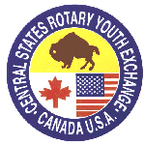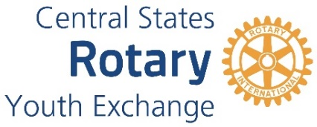

**ROTARY DISTRICT 6360**

**YOUTH EXCHANGE PROGRAM**

**Club Responsibilities for**

**Sponsoring an Outbound Student**

**To Sponsor an Outbound Student, a Rotary Club must formally approve support. The factors to support the program are:**

* To have a club member serve as a Youth Exchange Officer (YEO). This person will work directly with the student regarding paperwork and the selection process as well as follow-on during the exchange year.
* Promote Rotary Youth Exchange throughout your community seeking qualified students to apply. (High school foreign language classes, English classes, Interact clubs, faith-based youth groups, and 4-H groups)
* Distribute Pre-Application form to interested students and parents
* Conduct interviews of all students and parents that complete the Pre-Application Form
* Decide if the student, with supportive parents, will be a good candidate
* Refer all approved student candidates to District 6360 Outbound Coordinator for further application process.
* OPTIONAL: To provide financial support of approximately $1,000 for the year. (This can be in the form of a scholarship or providing the required RYE jacket, or other items.)
* If the student is selected to be a Rotary District 6360 Youth Exchange student, support the student and parents in the orientation process.

**NEXT STEPS:** See Outbound Student Timeline including estimated cost for next steps.

**District 6360 RYE Team Commitment to Your Club**

* District 6360 Outbound Team will work with your club YEO on processing of all required items.
* District 6360 RYE Team will provide training and information for YEO
* District 6360 RYE Team will actively support the club.

Attachments:

* Outbound Timeline
* Club Pre-Application form
* Club Pre-Application Instructions

